TASK 24:
import java.util.*;

class Solution {
public String minRemoveToMakeValid(String s) {
Deque<Character> stack = new ArrayDeque<>();
int unmatchedOpen = 0;

// First pass: remove invalid ')'
for (char c : s.toCharArray()) {
if (c == ')' && unmatchedOpen == 0) continue;
if (c == '(') unmatchedOpen++;
else if (c == ')') unmatchedOpen--;
stack.push(c);
}

// Second pass: remove invalid '('
StringBuilder res = new StringBuilder();
int unmatchedClose = 0;
while (!stack.isEmpty()) {
char c = stack.pop();
if (c == '(' && unmatchedClose == 0) continue;
if (c == ')') unmatchedClose++;
else if (c == '(') unmatchedClose--;
res.append(c);
}
return res.reverse().toString();
}
}

CASE 1:
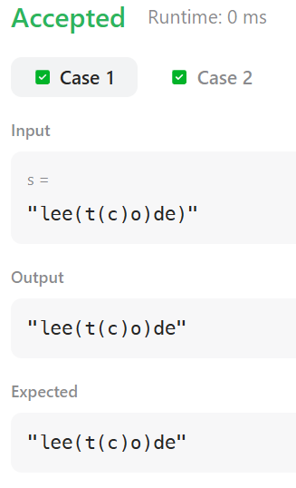
CASE 2:
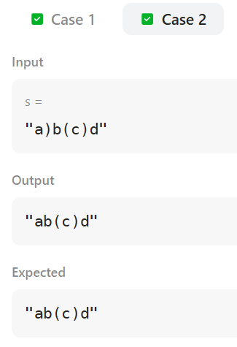
TASK 25:
class MinStack {
private Stack<Integer> stack;
private Stack<Integer> minStack;

public MinStack() {
stack = new Stack<>();
minStack = new Stack<>();
minStack.push(Integer.MAX_VALUE);
}

public void push(int val) {
stack.push(val);
minStack.push(Math.min(val, minStack.peek()));
}

public void pop() {
stack.pop();
minStack.pop();
}

public int top() {
return stack.peek();
}

public int getMin() {
return minStack.peek();
}
}

/**
* Your MinStack object will be instantiated and called as such:
* MinStack obj = new MinStack();
* obj.push(val);
* obj.pop();
* int param_3 = obj.top();
* int param_4 = obj.getMin();
*/

CASE 1:
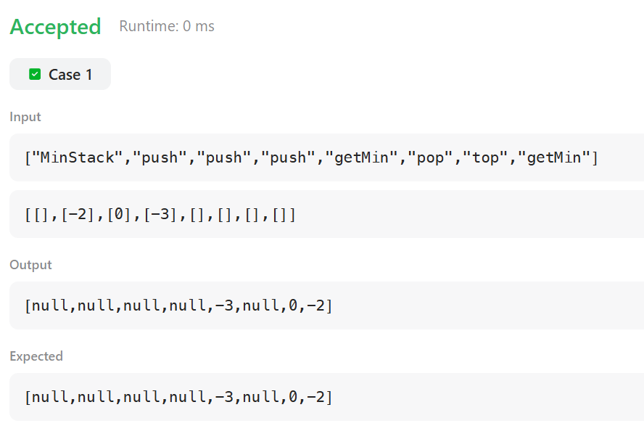
TASK 26:
import java.util.*;

class Solution {
public int[] asteroidCollision(int[] asteroids) {
Deque<Integer> stack = new ArrayDeque<>();
for (int ast : asteroids) {
boolean destroyed = false;
while (!stack.isEmpty() && stack.peek() > 0 && ast < 0 && !destroyed) {
if (stack.peek() < -ast) {
stack.pop();
} else if (stack.peek() == -ast) {
stack.pop();
destroyed = true;
} else {
destroyed = true;
}
}
if (!destroyed) {
stack.push(ast);
}
}
int[] result = new int[stack.size()];
for (int i = result.length - 1; i >= 0; i--) {
result[i] = stack.pop();
}
return result;
}
}

CASE 1:
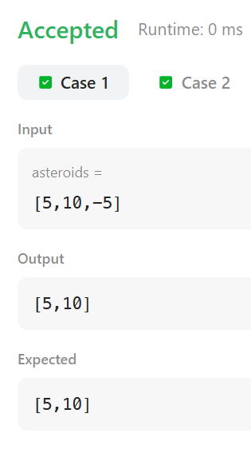
CASE 2:
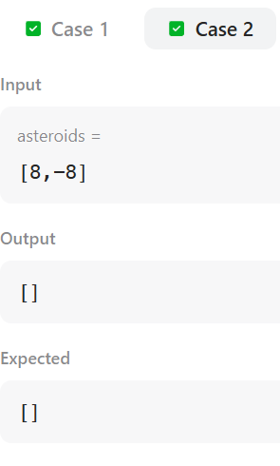
TASK 27:
import java.util.*;

class Solution {
public boolean validateStackSequences(int[] pushed, int[] popped) {
Deque<Integer> stack = new ArrayDeque<>();
int j = 0;
for (int i = 0; i < pushed.length; ++i) {
stack.push(pushed[i]);
while (!stack.isEmpty() && stack.peek() == popped[j]) {
stack.pop();
++j;
}
}
return stack.isEmpty();
}
}

CASE 1:
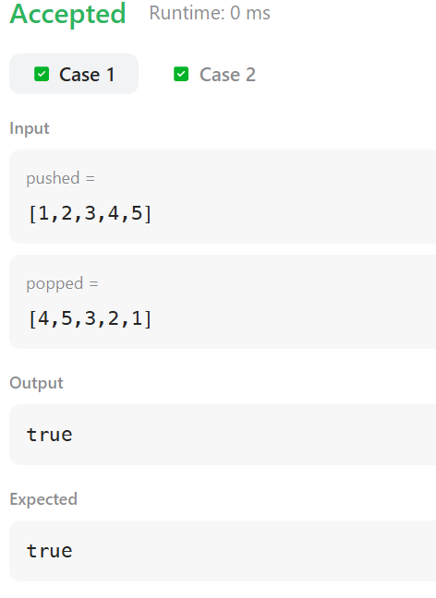
CASE 2:
